  - Name: Soniya Eknath Girhe. Sec_Batch_RollNo.: A7_B3_59.
  - Date: 20/01/2026.

Practical 01

Aim
Design a Java program to develop a Signal Processing System using object-oriented
principles. Create a class Signal with data members to represent the magnitude and phase
of a signal. Implement appropriate constructors to initialize the signal values. Provide
member methods to add two signals, scale a signal by a given factor, and display the signal
details. Create objects of the Signal class and demonstrate all functionalities using a suitable
main () method.

Program
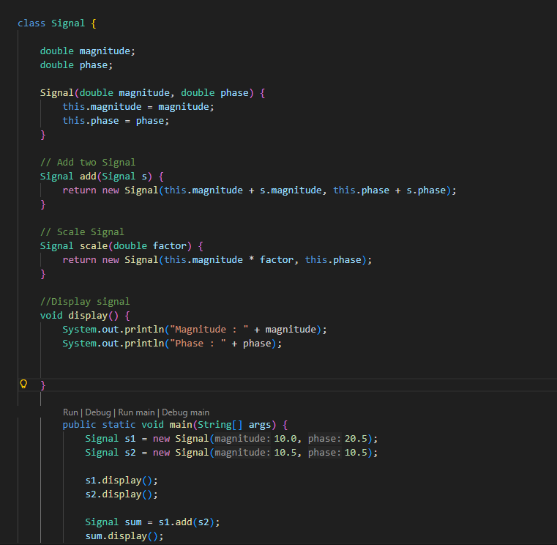
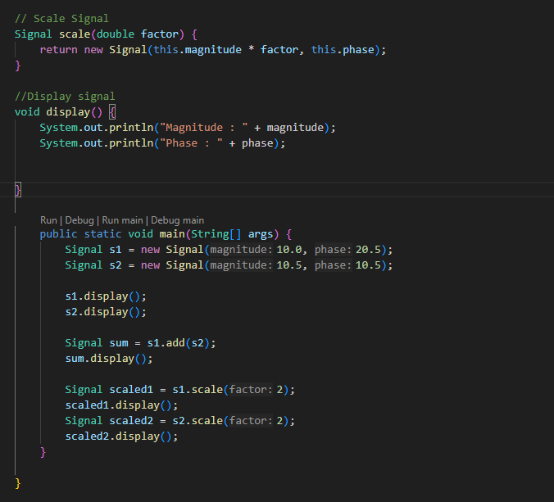

Output
